Class & User Management
In order to get started you will need to add the students to Oxford Reading Buddy with their nominate class details and year level included followed by adding the teachers.
Here is your step by step guide to class and user management:
Adding Teachers

Only the Organization Administrator can add new staff members.
If you are the Organization Administrator, follow these steps to add new staff members to Oxford Reading Buddy:
- Go to My Organization.
- Click the Staff tab.
- Click + Invite staff to open the following window.

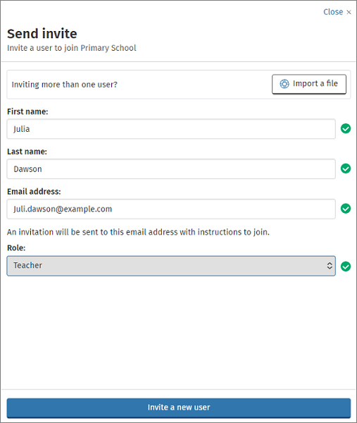

- If you are inviting one member of staff, enter their details and click ‘Invite a new user’.
- If you are inviting multiple staff members, you can save time by clicking ‘Import a file’.
- Click Download template and follow the on-screen instructions to complete. Please include all of the information specified in the Import users window: User name, first name, last name, email address and role. A list of roles are shown on screen and below. Choose the relevant teacher role based on the administration rights you wish the member of staff to have.

Role | Can do | Can’t do
Organization Administrator | Add, edit and archive students  Add, edit and archive classes  Add, edit and archive staff
Teacher Administrator | Add and edit students  Add, edit and archive classes | Archive students  Add, edit and archive staff
Teacher | Add students  Add classes  Edit and archive classes you are part of | Edit students  Edit and archive classes you are not part of  Add, edit and archive staff
- Once the file is ready and saved, click ‘Choose a file from your computer’ find the location in which you saved the file. Click next.
- You will receive a message to let you know your teachers have been loaded. Click Done.

Adding Multiple Students
Top tip: If you are adding students from Prep/Foundation enter “0” for their year group.

- Go to My Organization.
- Click the Students tab.
- Select Add Students.
- Click Import students.
- Choose your method of uploading students: ‘Copy and paste’ or ‘Upload a CSV’ file. Click on each option for an overview to help you decide which option suits you best. Click next.
- If you chose Upload a CSV file you can download a template if required.
- Save the template and populate it with your student’s details.
- Click ‘choose a file from your computer’ and find the location in which you saved the file. Click next.
- An overview of the students you are uploading will be presented, highlighting where there are any errors.
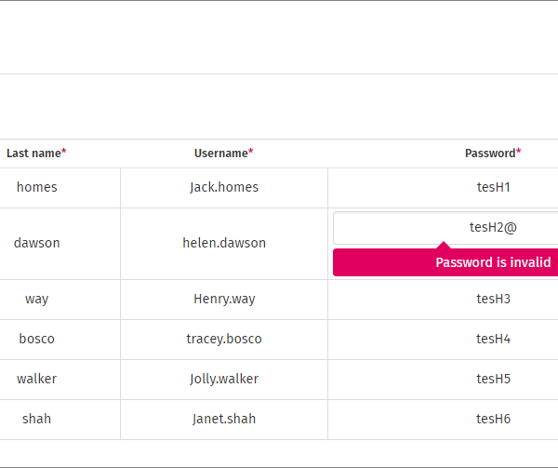
- Fix any highlighted errors and click next.
- Click Import users and then click done. You will receive an email to let you know if your import has been successful. Sign In cards for your students can be downloaded from this email. Your students will now be visible in the Students tab where you can edit or remove them at any time if necessary. You may need to refresh your browser.
Adding Individual Students

- Go to My Organization.
- Click the Students tab.
- Select Add Students.
- Fill in all of the boxes presented and click next
- Choose the year level the student is in and click Add student.
- You will see a confirmation and can generate the students sign in card. Once completed click done.
- You will now need to add the student to a class. To do so click on the classes tab.
- Find your class by using the search bar and click on the class name
- Click Add student and find your new student using the search bar. Tick the check box next to their name and click next and then click add to class. You can then click done. Your new student has now been added to the class.

Adding Teachers to Classes
- Go to My Organization.
- Click the Classes tab.
- Find your class by using the search bar and click on the class name
- Click on the teacher tab and then click Add teachers
- Search for the Teachers required using the search bar. Tick the check box next to their name and click next and then click add to class. You can then click done.

Resetting student passwords
- Go to My Organization.
- Click the Students tab.
- Select the student(s) whose password you would like to reset.
- Click Edit next to their name.
- Click Change password/Create Sign In card.
- Enter a new password or click Generate to create a random password.
- Click Save changes (and create Sign In card).
- The password has now been reset. Click done to close this screen, or Generate Sign In card. You can share this card with your students to inform them of their new login details.

Checking and changing a student’s Oxford Level

- Go to the reporting tab
- Click Class report and view your student’s auto placement. You can manually change a student’s Oxford Level.
- Select the student’s name from the list.
- Choose whether to Level up or Level down.
- If the student has already read at this level, all the eBooks and quizzes will be made available again.

